
Unit Title: Ethical Hacking and Counter measures
Unit Code: BIT4138
Unit title: Advance cryptography
Name: Abdi Yerowe Harbi -BSCCS/2024/57744
Project Title: Classical to Block Cipher Cryptographic Toolkit
Selected Technologies: Python, Vs code, cryptographic simulators, Statistical Tools
Github-Link: https://github.com/Abdi1425/Advance-cryptography

Contents
Week 1: Introduction to Classical Cryptography 3
Week 2: Stream Ciphers and PRNGs 4
Week 3: Period and Randomness Testing 5
Week 4: Stream Cipher Cryptanalysis 6
Week 5: Block Ciphers and Feistel Structure 6

Figure 1. Python implementation of Caesar and Vigenère cipher functions.‎ 3
Figure 2.Terminal output showing successful encryption and decryption of plaintext using both ciphers 3
Figure 3. Terminal output demonstrating a brute-force attack simulation on the Caesar Cipher.‎ 4
Figure 4. Implementation of the Linear Congruential Generator (LCG) class in Python.‎ 4
Figure 5.Terminal output displaying the pseudorandom sequence generated by the LCG.‎ 4
Figure 6. Terminal output showing the original, raw encrypted, and decrypted data using the XOR ‎stream cipher.‎ 5

Week 1: Introduction to Classical Cryptography
Comparison and Implementation of Caesar and Vigenère Ciphers
Implemented Caesar and Vigenère ciphers in Python. I observed that the Vigenère cipher provides enhanced security over the Caesar cipher by utilizing multiple alphabets via a keyword, which effectively reduces redundancy and makes basic frequency analysis much more difficult for attackers.
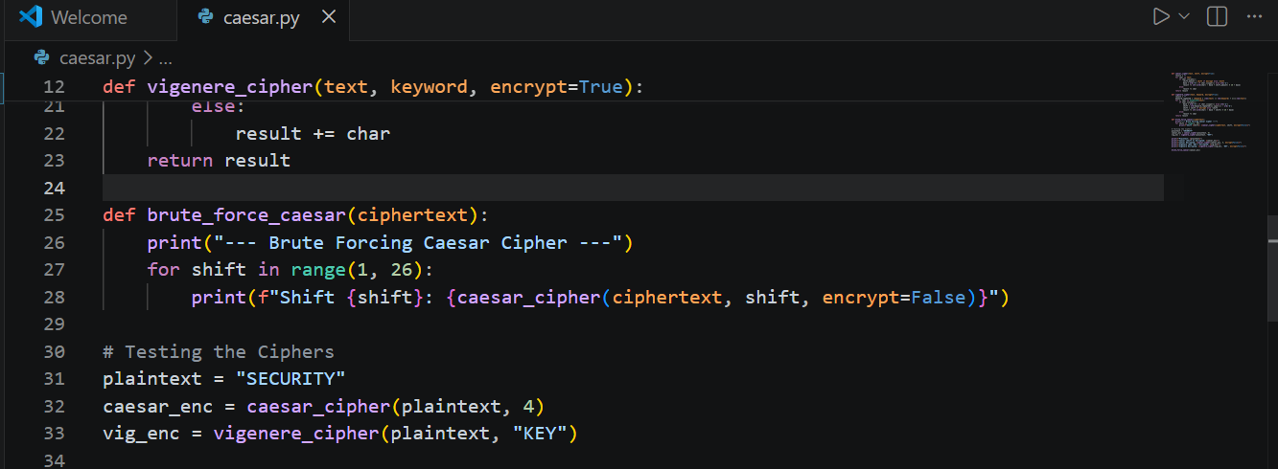
Figure 1. Python implementation of Caesar and Vigenère cipher functions.‎
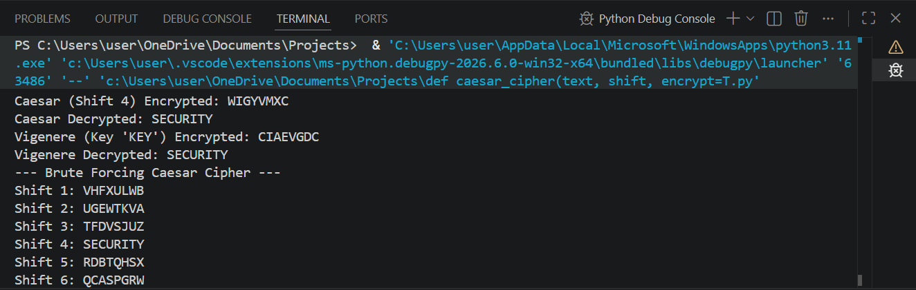
Figure 2.Terminal output showing successful encryption and decryption of plaintext using both ciphers

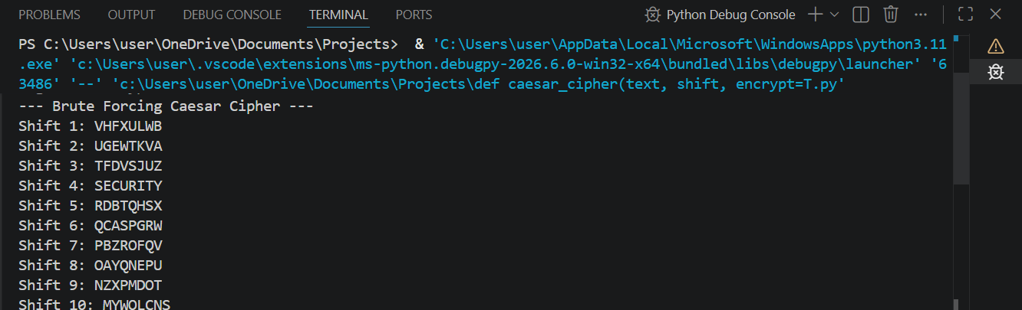
Figure 3. Terminal output demonstrating a brute-force attack simulation on the Caesar Cipher.‎

Week 2: Stream Ciphers and PRNGs
Implemented Caesar and Vigenère ciphers in Python. I observed that the Vigenère cipher provides enhanced security over the Caesar cipher by utilizing multiple alphabets via a keyword, which effectively reduces redundancy and makes basic frequency analysis much more difficult for attackers.
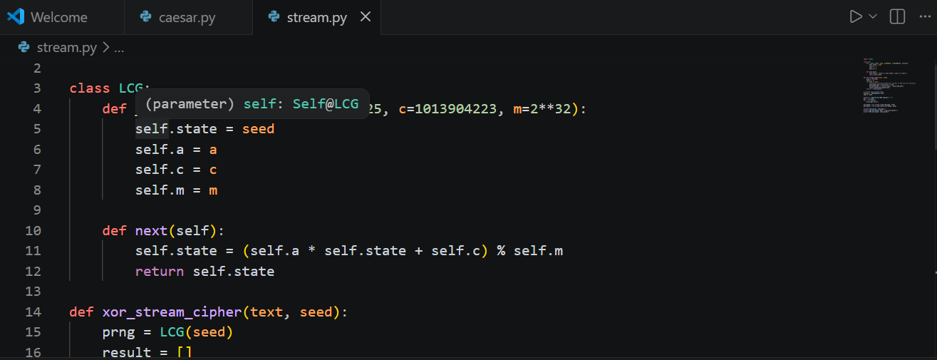
Figure 4. Implementation of the Linear Congruential Generator (LCG) class in Python.‎
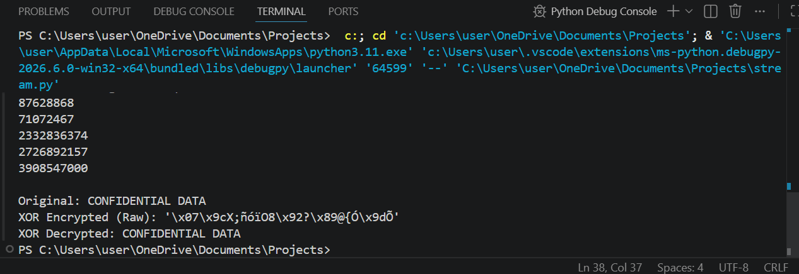
Figure 5.Terminal output displaying the pseudorandom sequence generated by the LCG.‎
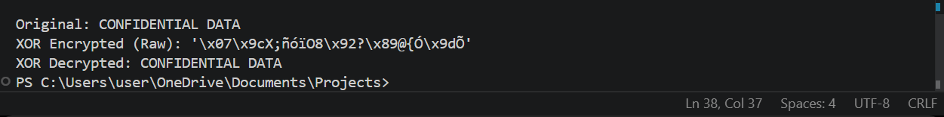
Figure 6. Terminal output showing the original, raw encrypted, and decrypted data using the XOR ‎stream cipher.‎

Week 3: Period and Randomness Testing

Conducted statistical randomness testing on pseudorandom sequences using Frequency, Runs, and Mean tests. I analyzed how the period and linear complexity determine a generator's strength, concluding that weak generators with predictable repetition patterns introduce severe security vulnerabilities into cryptographic systems.
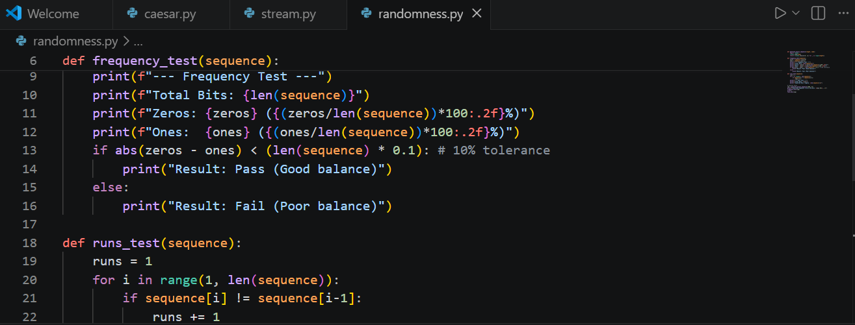

Fig 1: Python functions for generating binary sequences and executing statistical randomness tests.
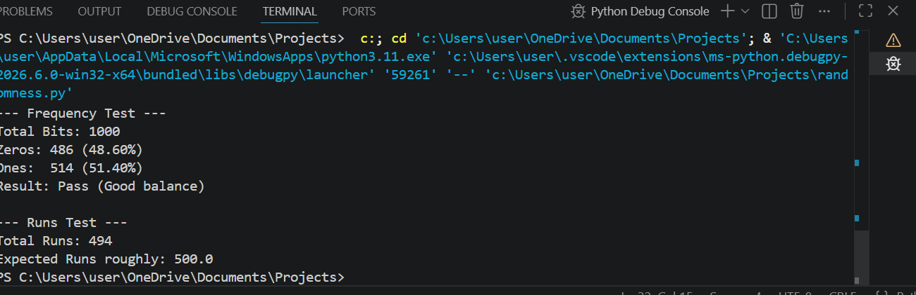
Fig 2: Terminal output showing the generated bit sequence and the results of the Frequency Test and run test

Week 4: Stream Cipher Cryptanalysis
Explored stream cipher cryptanalysis by implementing an LFSR and applying the Berlekamp-Massey algorithm. The practical demonstrated how an attacker can recover the linear recurrence relation of a sequence, proving that standalone linear generators are highly vulnerable to algebraic attacks without nonlinear components.
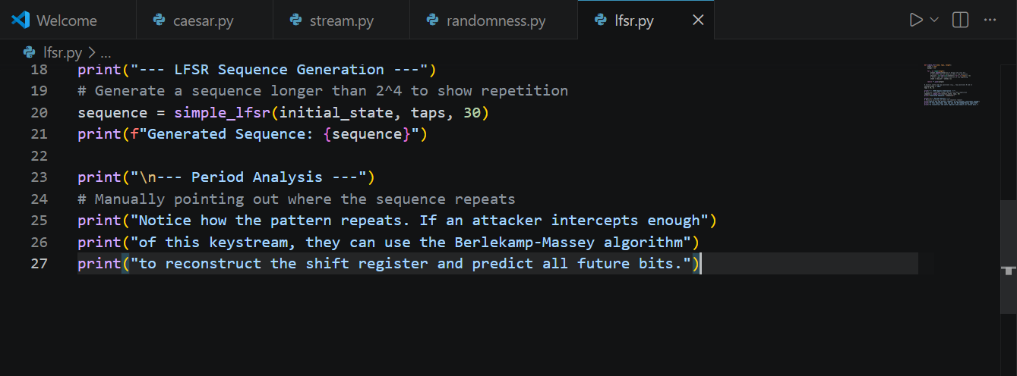
Fig 1: Python implementation of a Linear Feedback Shift Register (LFSR).
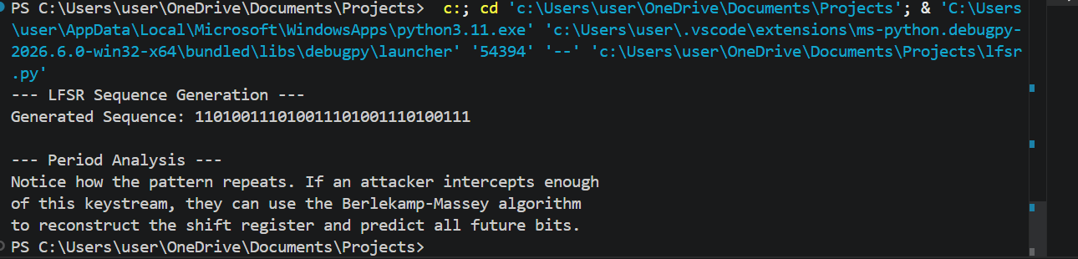
Fig 2: Terminal output showing the generated LFSR sequence and highlighting repeating states and explaining the sequence period and its vulnerability to algebraic attacks.

Week 5: Block Ciphers and Feistel Structure
Built a block cipher simulation based on the Feistel structure. By implementing multiple rounds of substitution and permutation, I observed how confusion and diffusion secure the ciphertext. The avalanche effect experiment successfully proved that minor plaintext changes propagate extensively throughout the encrypted output.

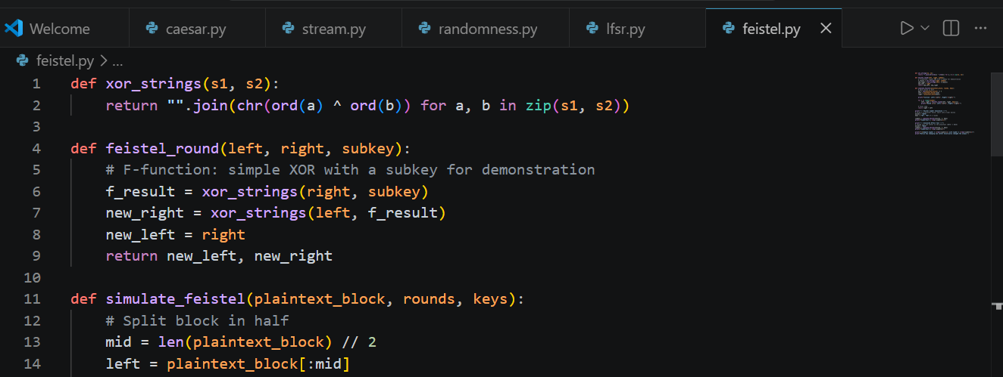
Fig 1: Python implementation of the Feistel network rounds and subkey operations.
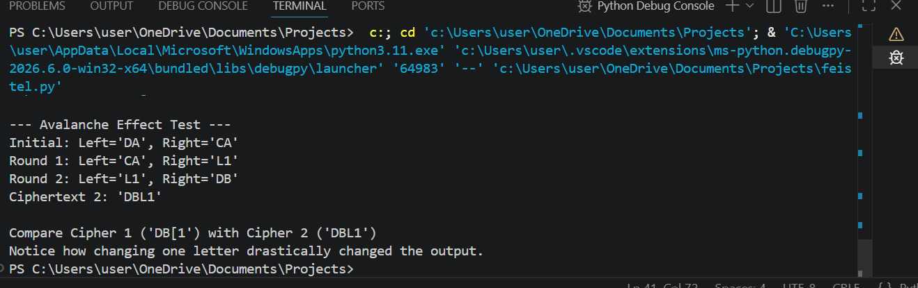
Fig 2: Terminal output demonstrating the block cipher simulation processing through multiple encryption rounds and Avalanche Effect test showing drastically altered ciphertext from a minor plaintext change.

